 Record of Progress:

TakeNote.

By Liam Harper

[1]

05/06/15 [2] –

The program is now capable of randomly generating a password based on preset strings in the program. The program uses a 3-D array and the program randomly chooses an index from these arrays in order to get a value. The three values taken from the 3-D array are concatenated together to create a random password. Initial implementation of converting the password to ASCII has also begun.

07/06/15 –

newbutton(i).location -> newbutton(i).top, left.

“i” comes out of loop as 2 for some reason

Figuring out how to let other sub-routine know which button caused it to execute

Need to fix re-dimming in form 1

Attempting to enclose encrypted string in junk

Why is passwordLetterConvertedToAscii() causing crash is () if > 99?

Redimming bypassed crash

However procedure call is invalid occurred on another line

Fixed via changing the chr method to .toint32. Magic

Anddddd, on the 8th of June .toint32 became the problem and had to be put back to chr with no problems at all. Magic???

Need to convert output (variable that stores our random output of 2 letters) into array. Because……

Let’s say output = random letter + random letter

Output = xy

If we try to call output when we are concatanising our random strings and our split up encrypted password together in a counter of let’s say 4…

We’ll get xyxypwxyxy.

Very predictable.

08/06/15 –

Our algorithm for retrieving our Caesar Ciphered letters from the junk had problems. After thought and trial and error we successfully were able to calculate which letter was where and separate it from the junk.

Code needs a MAJOR cleanup. Absolute mess.

Decrypting generated password does not work. Custom password does. Will find fix. 2 minutes later problem potentially found. We are only encrypting the variable for the custom password and are not even touching the generated one. Oops.

^ 20 minutes later and yes that was the problem. Rather than having a separate variable for the custom and generated password they now have the same name of initialPlanTextPassword. Eliminating the previous problem.

Re-ordering of sub-routines. Stupid placement. Had authentication sub-routine in another form for some reason. Created so much problems.

Some more commenting done. Will most likely be altered again once clean-up occurs.

If we have an empty note file our button looks invisible on the form due to the text in the button being from the first line of the text file. A condition has been added that changes the text of the button to “empty” if the text file is empty.

Minor design edits. E.g. removing space in title of program on form.

Added cursor element to main form button to let know user know it can be clicked. Should add to rest of buttons at other time.

09/06/2015 –

Attempted to create char array that would contain the alphabet in order to scan each drive for our password file without user intervention.

However once we got to a particular letter the program would crash. Originally I thought this was the E drive which was where our file was hosted. However in actuality the drive was D. This means that our program is reading the empty DVD drive which will return an error due to having nothing there.

So we can now determine which drive to read our password from without user intervention and eliminate crashing via having the program attempt to read from somewhere where the file does not exist.

A condition has been re-configured throughout the program that determines whether or not the file has been found.

Our program now scans for a drive to write to when it needs to create the original password file rather than having a set directory. Our program uses removable drive letters as preference then moves to internal drives.

10/06/2015 –

Program now outputs text files last modification date.

Thanks to this we are now warning-less!

Background for program has been changed. Font has been changed from Microsoft Sans Serif to Gothic720 Lt BT for a cleaner look.

lastModificationDateButton(i).Name = "notes" & i must be modified. Changing name causes crash due to other sub-routine trimming everything behind the 5th letter. In the context of notes5 this will give us the number 5 and in turn this tells us that the the file being opened is the 5th file in the list.

Lines are now being generated in the program rather than pre-set in order to accommodate an increasing number of text files on the form. This is in the process of being implemented correctly.[3]

Created user survey so I can find out what people want in the program.

11/06/2015 –

Lines are now also generated in the form that outputs the text from the notes. Almost there!

We can now make changes to the imported text file within the program. The program now accomplishes the initial aim!

Now to re-write 50% of it to use a database rather than a text file. :^)

12/06/2015 –

Project Specification completed and approved by teacher. Survey has also been answered within the class.

16/06/2015 –

Dates now display in descending[4] order. In accordance to this the program must now sort the buttons that open the text files in order of date.

17/06/2015 –

Have begun the requirements specification. Further implementing the date and button being side by side in ascending order in program.

19/06/2015 –

The requirements specification has been further progressed. The program has not been altered from previous.

23/06/2015 –

Converted 3-D array to 2-D array. In terms of x y and z x was completely useless.

Our program now uses a database rather than hard-coded values in the program in order to generate our password. The migration from a text file to a database is going well!

24/06/2015 –

The program now writes and receives the random string generated in the program to and from the database. The use of a text file for a password is now no longer needed! This will later be expanded to the notes in the program to completely remove the use of text files for the program. The code for implementing the database usage needs to be cleaned up. Duplicate variables everywhere…

24/06/2015 (14:23) –

Which I just cleaned up 5 minutes after typing that. Welcome form as a whole has been cleaned up. Reduction of 60 lines of useless code. Database field is too small to accept random strings created from the generated password. SHA-2 must now be implemented. In preparation for this I have imported System.Security.Cryptography.

25/06/2015 –

System.Text must be imported in order to create a StringBuilder.

SHA-256. IS. DONE. FINALLY. ARGHHHHHHHHHHHHHHHHHHHHH.

26/06/2015 – THE PURGE

The code in form one has been nearly halved from 581 lines to 373 lines.

This is due to an encryption overhaul that has involved replacing the deprecated Caesar Cipher method with the implementation of SHA-256 encryption.

Two sub-routines that involved the converting and de-converting the password to and from ASCII are no longer necessary and have been removed.

The sub-routine that generated junk is now also deprecated and is replaced by a sub-routine that generates a salt. The junk sub-routine was flawed due to the number of junk characters having a direct correlation with the length of the entered password. The longer the password the larger the appended string of junk was. Due to the fact that fields in a database have a max character count of 255 this became impossible to implement to a usable standard.

A randomly generated salt is also implemented that is added to the database. This salt is also appended to the user’s inputted password for transport into the sub-routines that handle the conversion of plain-text into a hash via SHA-256 encryption in order to further secure the hash.

The salt is implemented because in a scenario where an attacker has a database of hashes and a powerful GPU they can potentially check billions of common passwords a second. Simply adding a hash of “test” into the database would result in the hash being cracked in seconds. However the chances of an attacker having a hash of “testdndidiwnd87” is unlikely and the attacker would have to rely on much slower methods such as brute-force and rainbow tables.

26/06/2015 – 21:46

Program now encrypts and decrypts the SHA-256 encoded hash (which was further secured with the salt) for both user-inputted password and a randomly generated password. The previous method of encryption (Caesar Cipher with ‘junk’) has been completely replaced for a much cleaner and efficient method.

The code in general has been cleaned up. Removing unused variables that were involved with the previous encryption method.

The sub-routines were re-organised in the programming environment in order to better reflect the programs chain of events for increased readability.

90% of commentary in the ‘Welcome’ form is completely useless. Commentary for the ‘Welcome’ form needs to be re-written.

Changed some sub-routines from public to private for added security. They were previously public in order to easily pass variables across forms.

29/06/2015

Detailed Project Proposal completed. This involved detailing resources such as required software and refining the initial project proposal to take into account changes in the program (the change in encryption for example). Gantt chart has also been created to co-inside with it.

29/06/2015 – Not 00:00 in the morning edition

OUR PROGRAM FINALLY SORTS THE TEXT FILES IN ASCENDING ORDER. The problem that has plagued the program for about 2 weeks has finally been solved by implementing IComparer. IComparer allows us to compare the last write times between two objects at the same time. (File1 and file2 etc). We can then sort these write times into descending order and simply iterate through the array containing the descending values in order to allow the user to see their last worked on file at the top of the list of files rather than in a random spot!

To fully implement this our form that lists the text files had to be slightly rewritten. The only significant changes were the altering of variable names and the movement of the cluster of redim’s to further up the form.

Also, our program is no longer called ‘3-D Array Test’ as it is now way beyond a simple 3-D array test like it was originally intended to be! To reflect this a few lines of code where changed to take into account the change in directory name.

However by far the most important change was fixing a misaligned label on the form that displays the GIF of the pug with horns.

30/06/2015 –

Program now accepts newly written notes and writes the text and the write time into the database rather than writing the text to a text file. The new challenge is to read the notes from the database and display them on the noteSelection form in the same manner as it does with the text files. This will completely replace our current system of using the file system itself as a resource to obtain the last write time of a text file.

01/07/2015 –

Program has been setup to read the first instance of a note in the database. The program now needs to be altered in order to accommodate multiple notes (e.g. an array).

02/07/2015 –

Program now reads all records in the note table and takes them in as an array.

07/07/2015 –

Development is now taking place using Microsoft Visual Studio Community 2015 RC rather than Microsoft Visual Basic 2008 Express Edition. This means that the program underwent an automatic conversion process and will now be incompatible with the previous platform. The results of this conversion can be viewed in the file UpgradeLog.htm. The reason for the change is simply preferring to use the newest possible development software rather than the outdated version used previously (also the darker interface is easier on the eyes at night time).

The program now sorts data taken from the[5] database into descending order. We are now in the same position as we were with the text files. This means that the migration from using text files to a database is now complete.

A problem encountered was that the program was sorting the entries incorrectly. For example sorting into descending order resulted in the following:

| **notes** |
| --- |
| **lastWriteTime** |
| 01/06/2015 |
| 03/06/2015 |
| 03/06/2015 |
| 12/06/2015 |
| 14/06/2015 |
| 16/06/2015 |
| 18/06/2015 |
| 20/06/2015 |
| 22/06/2015 |

As you can see we *almost* have the correct result but a few entries are incorrect. This was solved by changing the data type of the field containing write times in the database from ‘Short String’ to ‘Date/Time’.

The program is now able to refresh the contents of the notes during runtime rather than having to close and re-open the program to view the newly changed contents. This is done by clearing the form (NoteSelection) that handles the displaying of the preview of database notes from memory upon clicking a button that handles the opening of the users selected note (NoteViewer). Then upon closing the NoteViewer form NoteSelection then re-initialises. Thus re-running the start-up code and displaying the updated database.

The filename label that was on the NoteSelection form that was used as a workaround to pass the filename across forms has now been removed as it is no longer needed.

The program also now has an icon that is displayed to the user in the task bar and also the title bar. The assembly information was also altered from its default to match the program.

Upon using the code analysis feature of Microsoft Visual Studio Community 2015 RC the following warning was given.

|  |  |  |  |  |  |
| --- | --- | --- | --- | --- | --- |
| Severity | Code | Description | Project | File | Line |
| Warning | CA2122 | 'Welcome.GetSalty(ByRef String, ByRef String, OleDbConnection, ByRef String, String, Boolean, ByRef String)' calls into 'FileSystem.Dir(String, FileAttribute)' which has a LinkDemand. By making this call, 'FileSystem.Dir(String, FileAttribute)' is indirectly exposed to user code. Review the following call stack that might expose a way to circumvent security protection: ->'Welcome.GetSalty(ByRef String, ByRef String, OleDbConnection, ByRef String, String, Boolean, ByRef String)' ->'Welcome.GetSalty(ByRef String, ByRef String, OleDbConnection, ByRef String, String, Boolean, ByRef String)' | TakeNote | G:\S6\TakeNote VS 2015\TakeNote\1. Welcome.vb | 157 |

This was solved by changing the sub initialisation from public to private.

The programs UI has been altered significantly especially in the start-up form. The start-up form now looks more presentable as an icon has been added and a better looking font (Segoe UI Semilight) has been used. The background image that was used as the background on all forms has now been removed and a simple white background is now used as a better looking replacement. The Save button on the NoteViewer form has been altered to look like the New button on the NoteSelection form.

Upon running the build version of TakeNote it seems that the program fails to exit correctly. If the program is closed on the NoteSelection form it seems from a user’s perspective that the program has closed. However upon inspecting Task Manager the program is still residing in memory. If the program is closed on the Welcome form this does not occur. I suspect this is related to the programs use of accessing the database on that particular form. This will have to be addressed immediately as hypothetically if a user uses the program frequently and never resets their machine this will result in an ever-increasing number of TakeNote processes running in the background unbeknownst to the user.

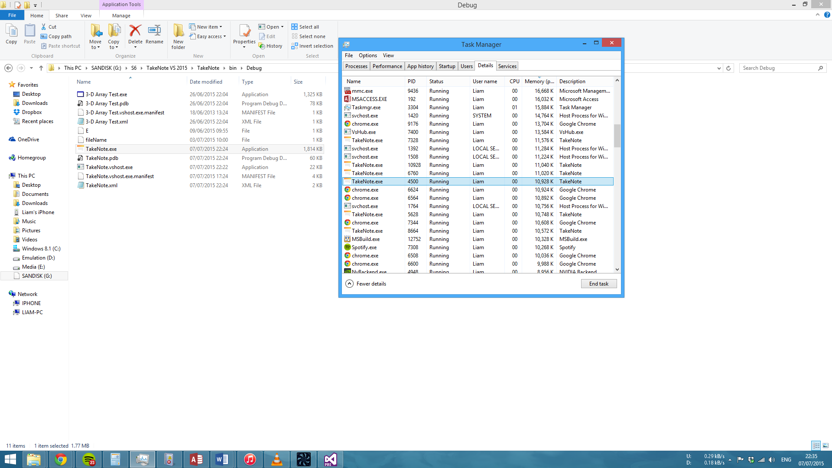

As you can see from the example here simply repeating this five times results in almost 60Mb of memory being consumed.

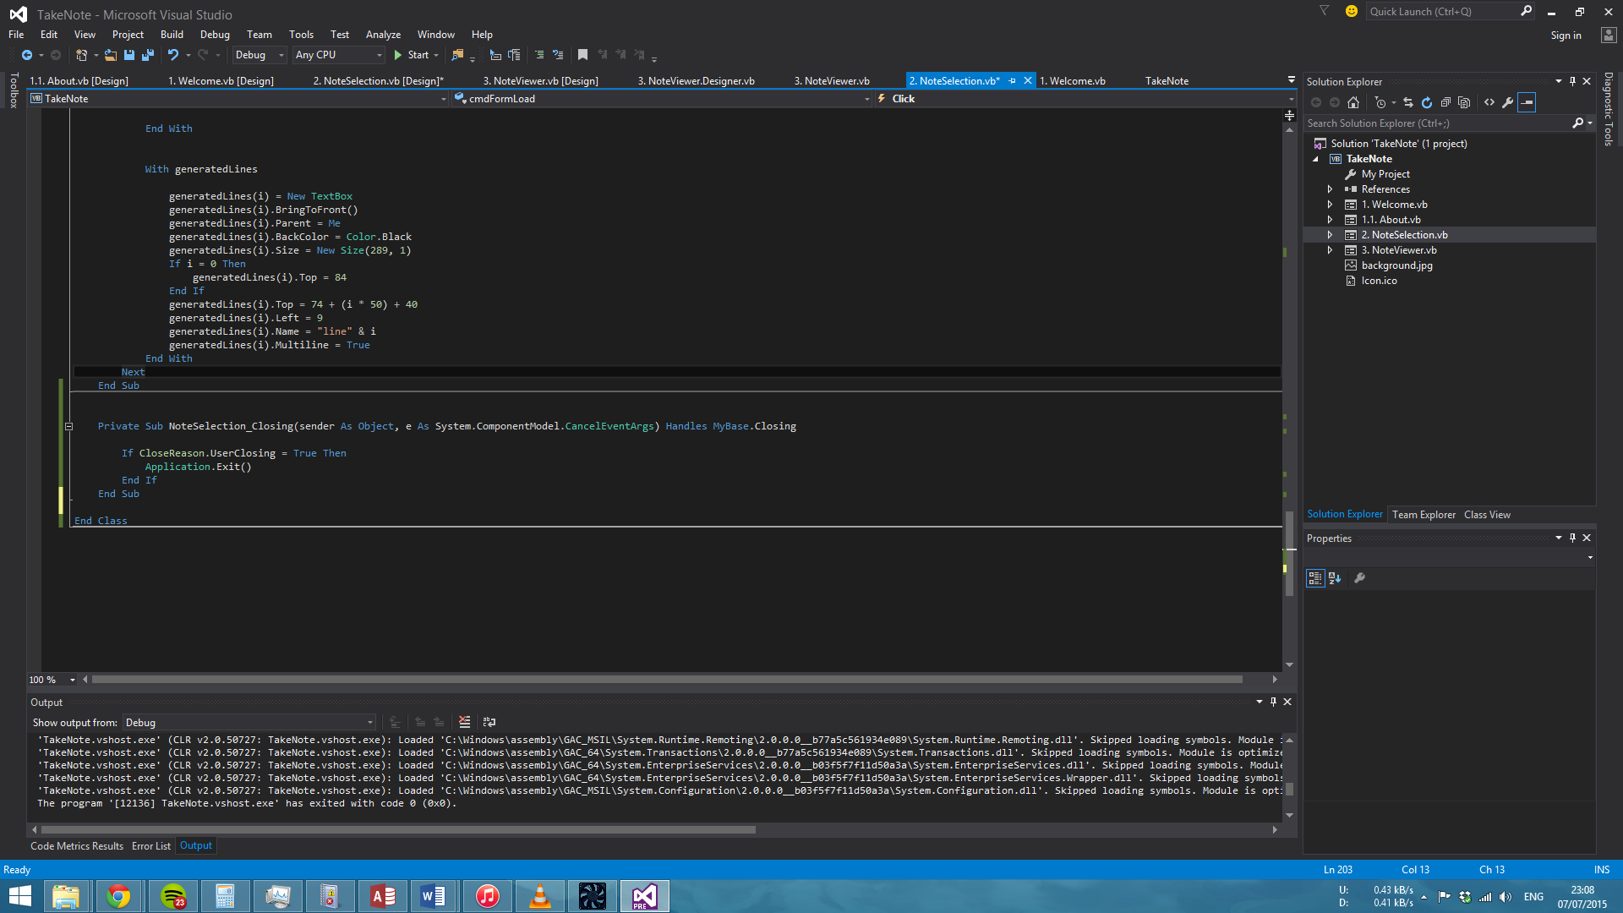

Using the above code that runs if the form is in a closing state amends this problem. As our program already closes this form upon opening NoteViewer in order to refresh the contents of NoteSelection by reloading it later a condition has to be added that means that the above code will only run if the *user* closes the form (for example clicking the top right cross).

08/07/2015 –

The program is now capable of recognizing whether or not the note being written is either new or is a modification of an already existing note in the database. Upon recognizing this the program acts appropriately. If the note is new then the program creates a new row in the database consisting of the note itself and the date it was written. If the note is a modification of a current note then the program amends the dataset of the table that the program creates during runtime with these new changes.

For example:

Upon initialisation of the NoteSelection form our table called “notes” in the database is converted into a dataset for use in the program and upon inspection the dataset initially appears as so –

|  |  |  |
| --- | --- | --- |
| ID | note | lastWriteTime |
| 13 | testy test1 | 08/07/2015 00:00:00 |
| 1 | write123 | 08/07/2015 00:00:00 |
| 3 | test62 | 07/07/2015 00:00:00 |
| 2 | test623 | 07/07/2015 00:00:00 |

This dataset will then be altered on the NoteViewer form taking into account the users specified change –

|  |  |  |
| --- | --- | --- |
| ID | note | lastWriteTime |
| 13 | testy test1 more testing here | 08/07/2015 00:00:00 |
| 1 | write123 | 08/07/2015 00:00:00 |
| 3 | test62 | 07/07/2015 00:00:00 |
| 2 | test623 | 07/07/2015 00:00:00 |

This dataset is then written to the table in the database and overwrites the previous data.

During the process of implementing this the following error was encountered:

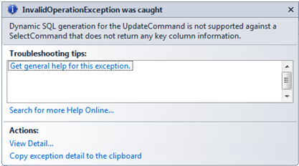

This was caused by the table being used having no primary key and in turn no key column information. This was resolved by creating a new table and copying the data from the older table over. The new table has an ID field containing a primary key.

The program now also has the horizontal scrollbar disabled in the NoteSelection form.

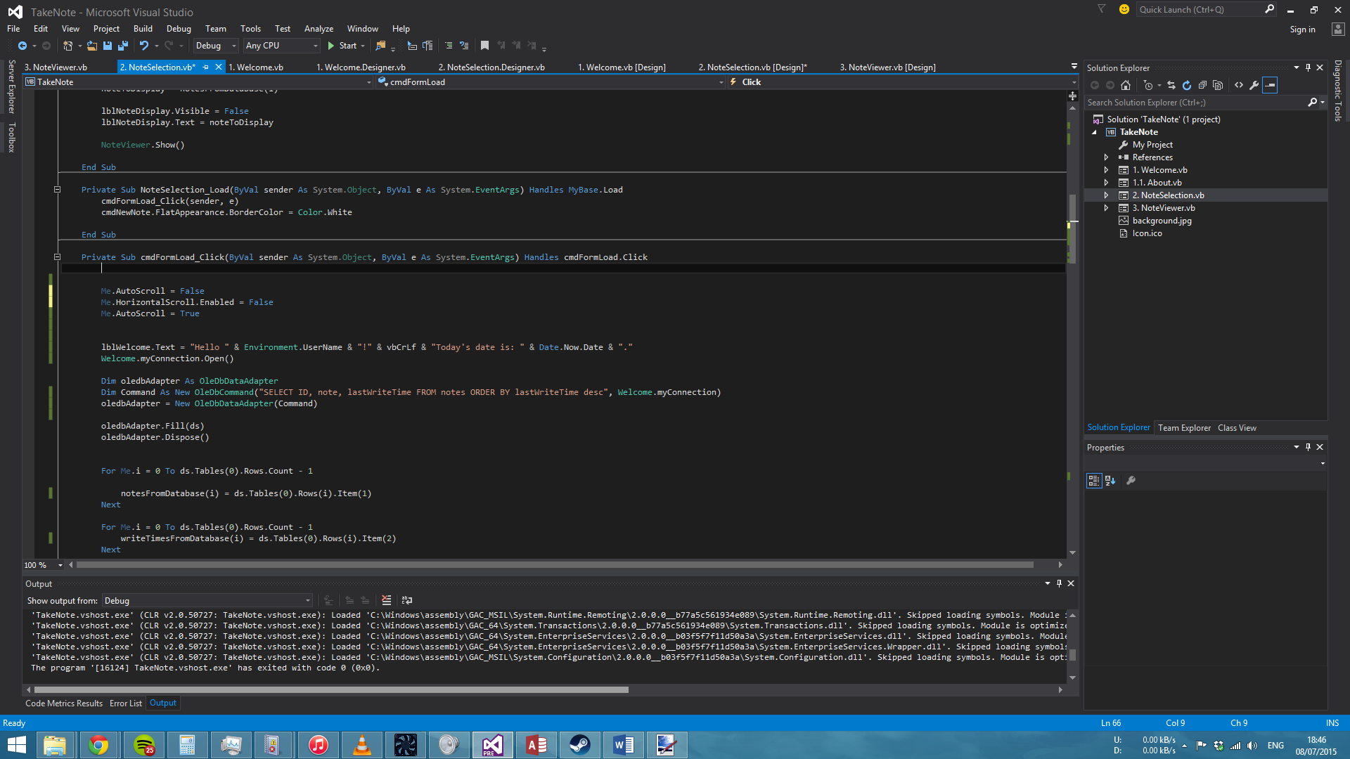

AutoScroll is a must in the program in order to take into account the increasing number of notes on the NoteSelection form. However AutoScroll automatically implements this vertically *and* horizontally. Due to the way that aspects such as the lines and buttons themselves are generated being able to move horizontally means that the user will encounter blank spaces. As this creates an untidy UI this had to be altered.

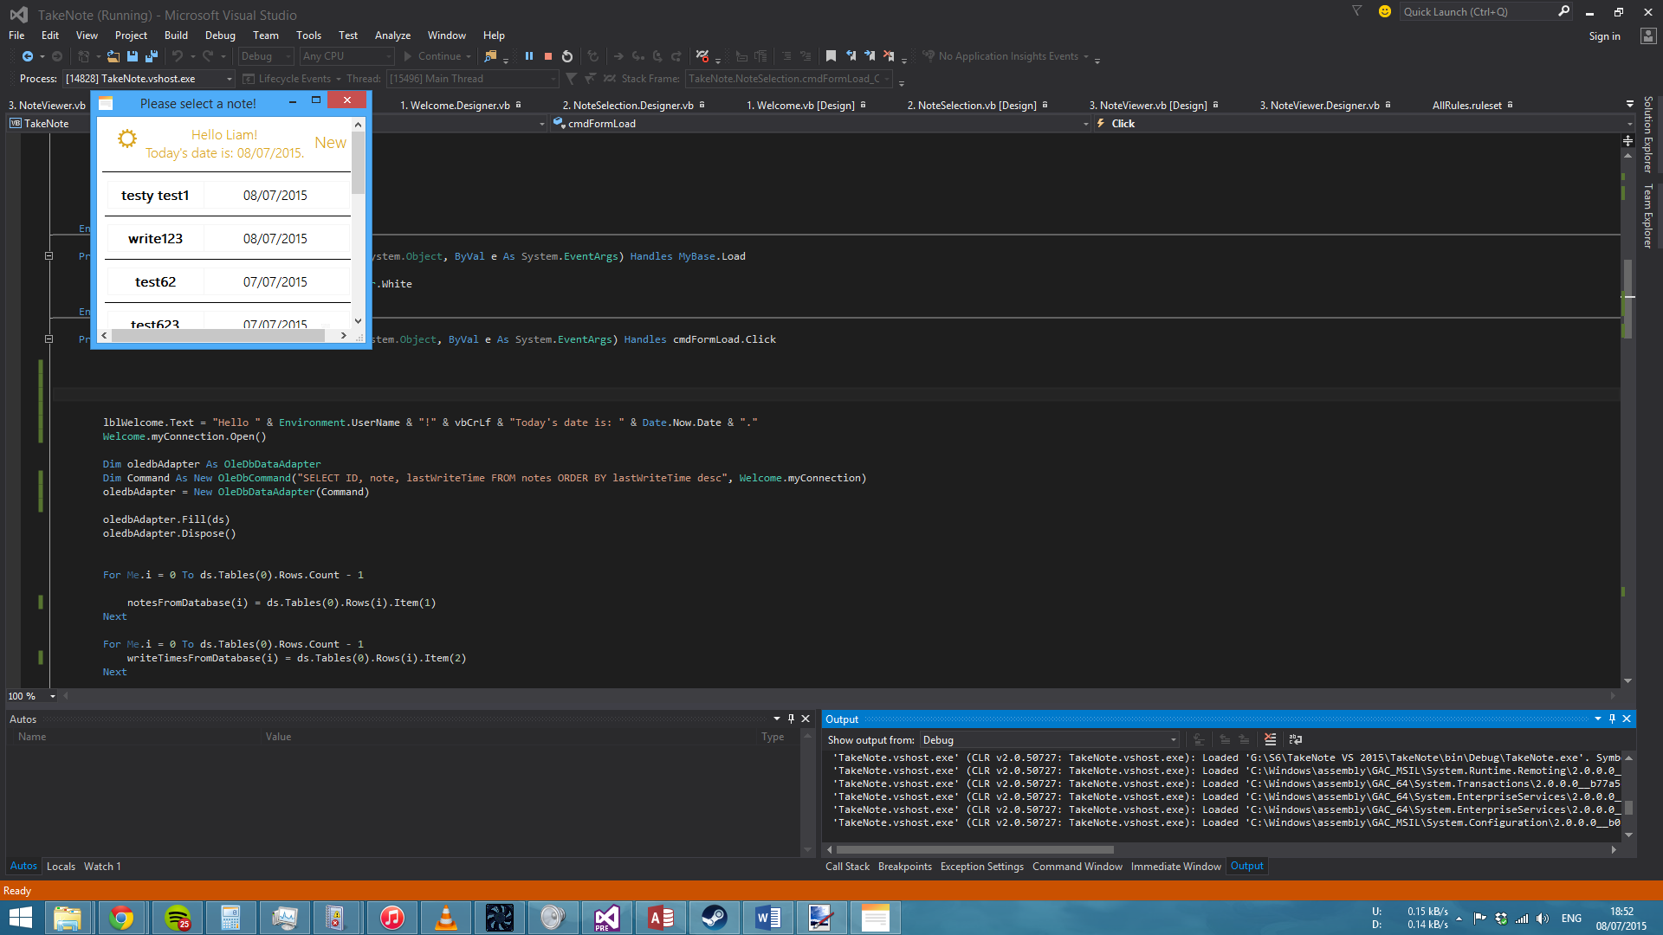

As you can see there is a blank area in which the lines do not cover. This will exist no matter how much the dimensions of the lines are changed.

Once the implementation is in place the dimensions of the lines were altered from “289, 1” to “300, 1”.

All controls in the program are now appropriately named.

Changed the font and font colour in the about form to match the others.

The dimensions for the generated lines in the NoteViewer form has been adjusted from “336, 1” to “345, 1”.

The program now tells the user that modifications to files have been made such as making changes to the database by creating a new note. However the program does not check if the changes have occurred and the changes being made is only a presumption based on the fact that the code completed. Verification will have to be added.

The UI of the program can now be changed via user request. A new form called ‘Settings’ has been created and this allows the user to choose from either the default ‘light’ theme or a ‘dark’ theme.

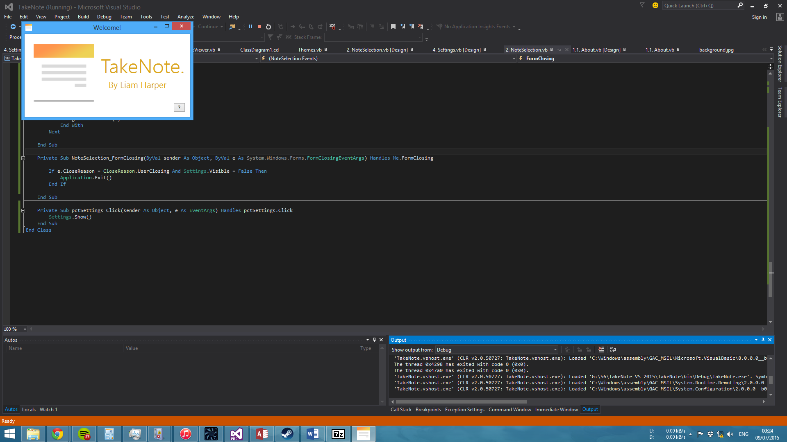

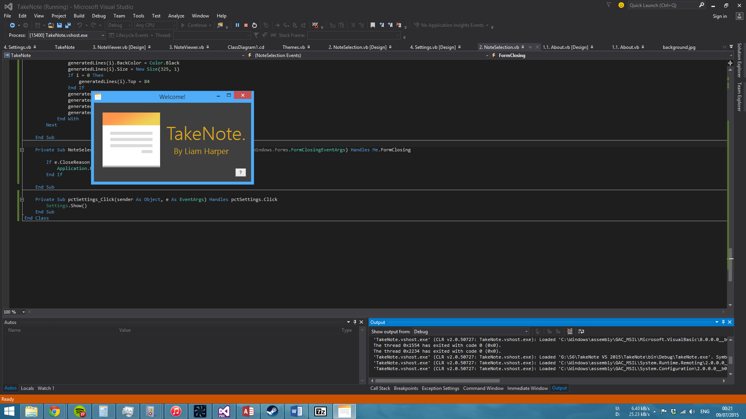

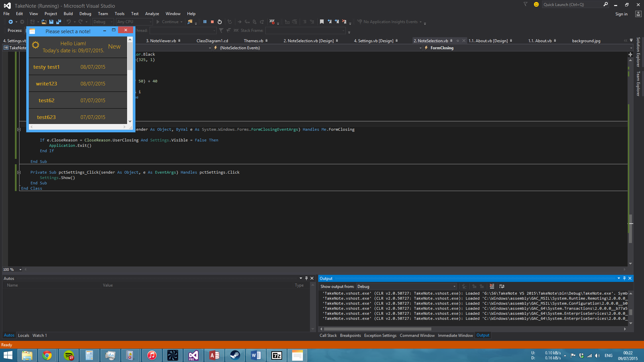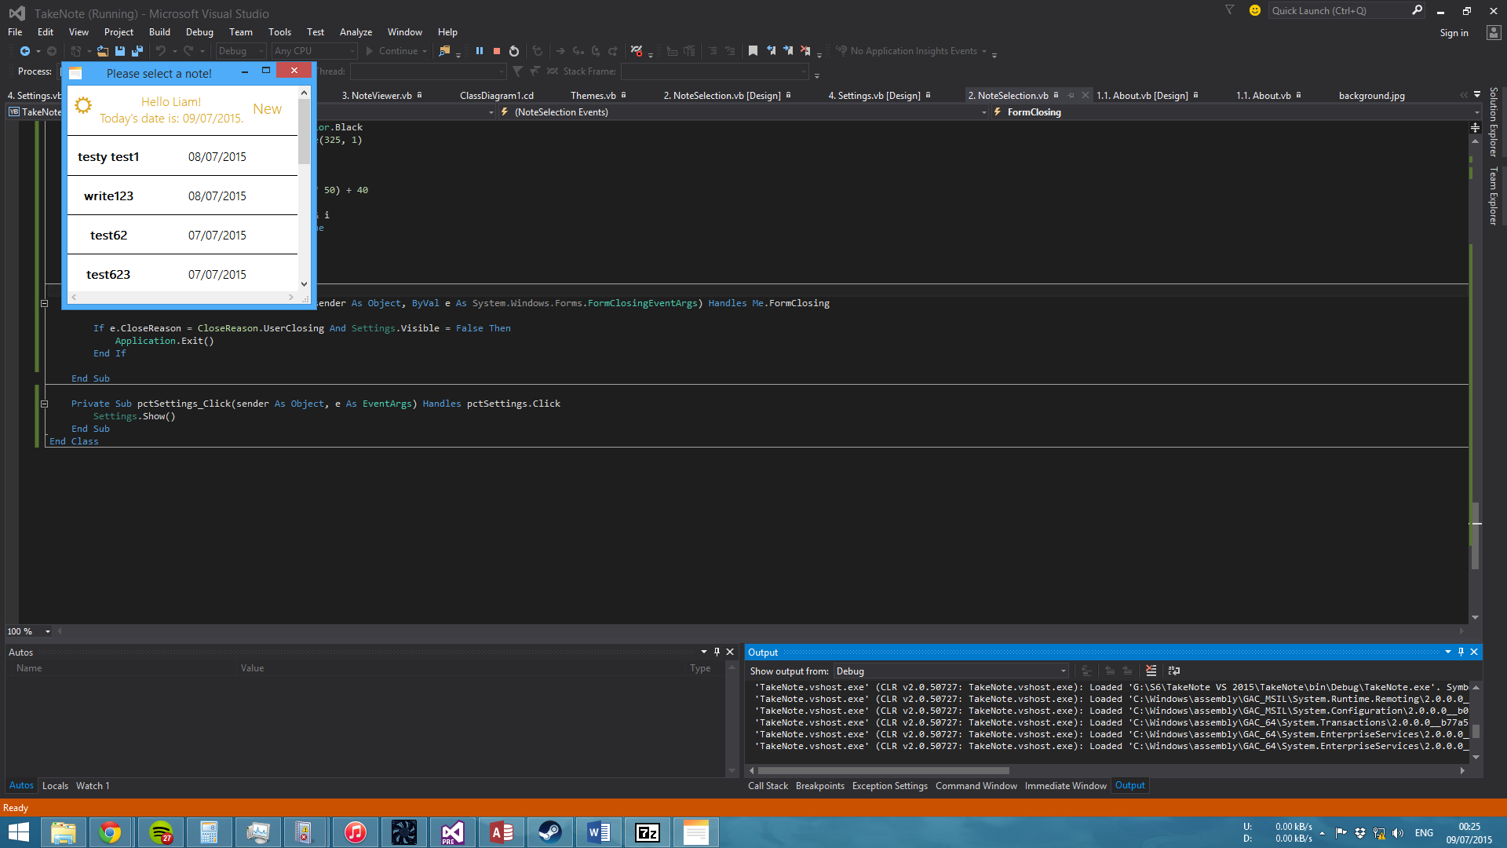

The text on the ‘light’ version is easier to read than it presents itself through the screenshot.

This was implemented via the use of the Application Settings feature in the programming environment.

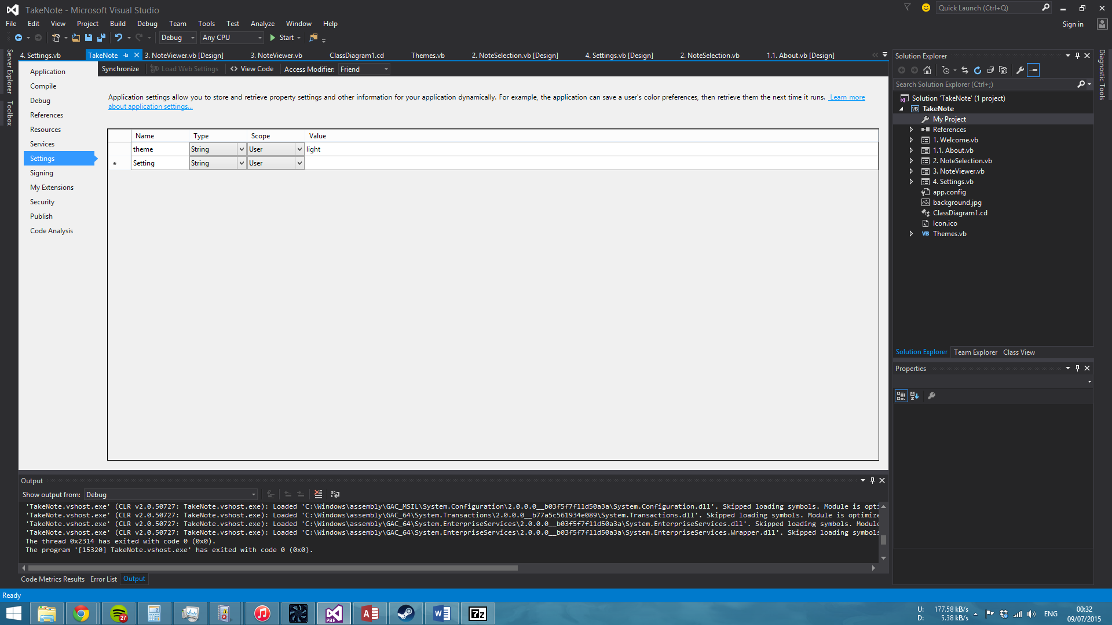

In the Welcome form the button that displays “TakeNote.” and directs the user to the subsequent form has been changed to a label in order to counter the highlighting effect that appears over the button when the mouse is over it. This was intrusive to the interface.

The program had begun to refuse to kill the process once again on the NoteSelection form. This was regardless of having the code that was implemented the day before.

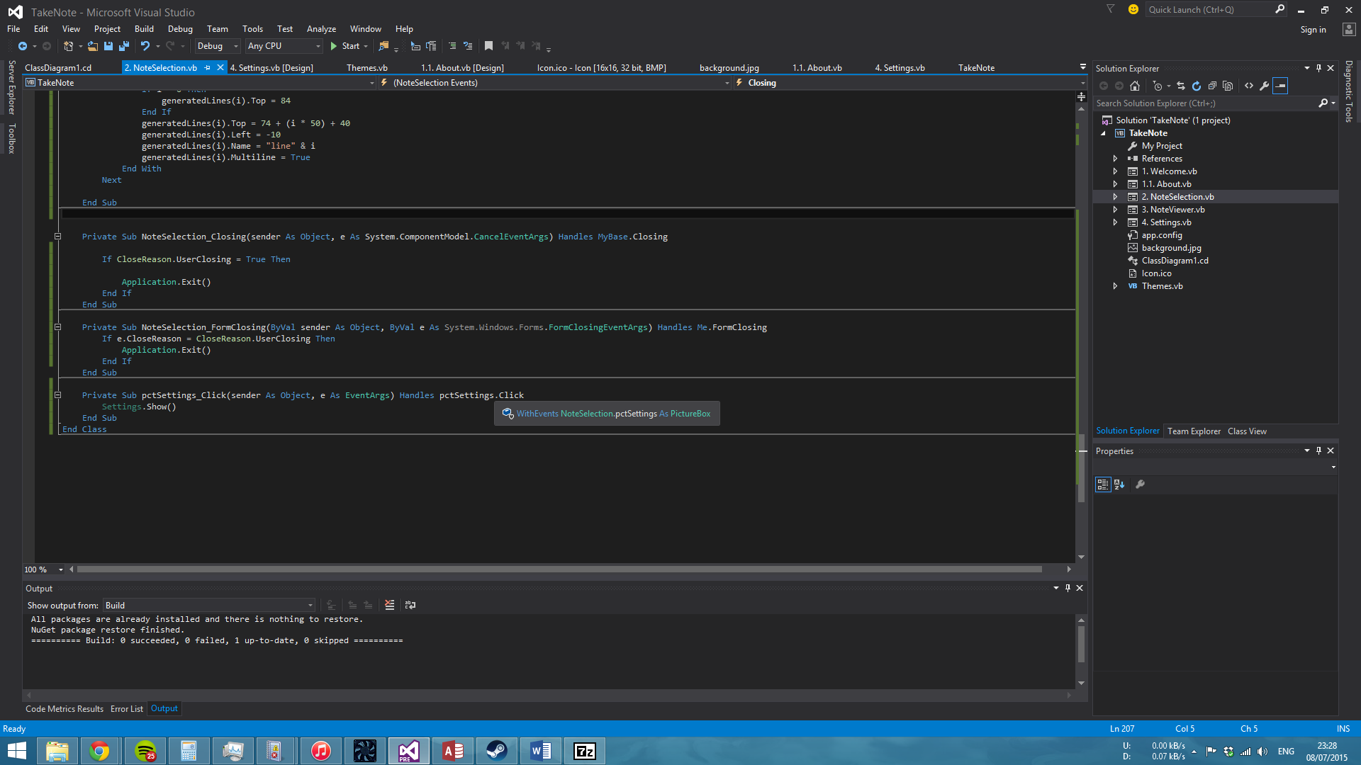



The change to the above code fixes this problem. Again.

However. Later it became clear that this would not work. In the NoteSelection form the generated buttons have a back colour that is specified in the code (this can be changed between light and dark via the use of If statements which check the value of my.settings.theme). The Settings form cannot modify the back colour without closing and re-opening the NoteSelection form and allowing the If statements to influence the back colour. Closing the form via clicking a button seems to fall under a userClosing event. To counter this the check will only go through if the form is being closed while the Settings and NoteViewer form are not open.

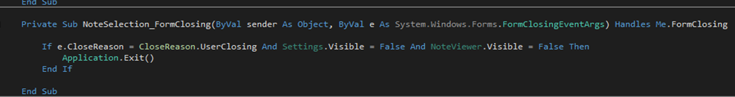

The NoteSelection form has also been modified to make the user feel more welcome. The program receives the user name of the Windows logon account and outputs it via the label in order to make the program feel more personal.

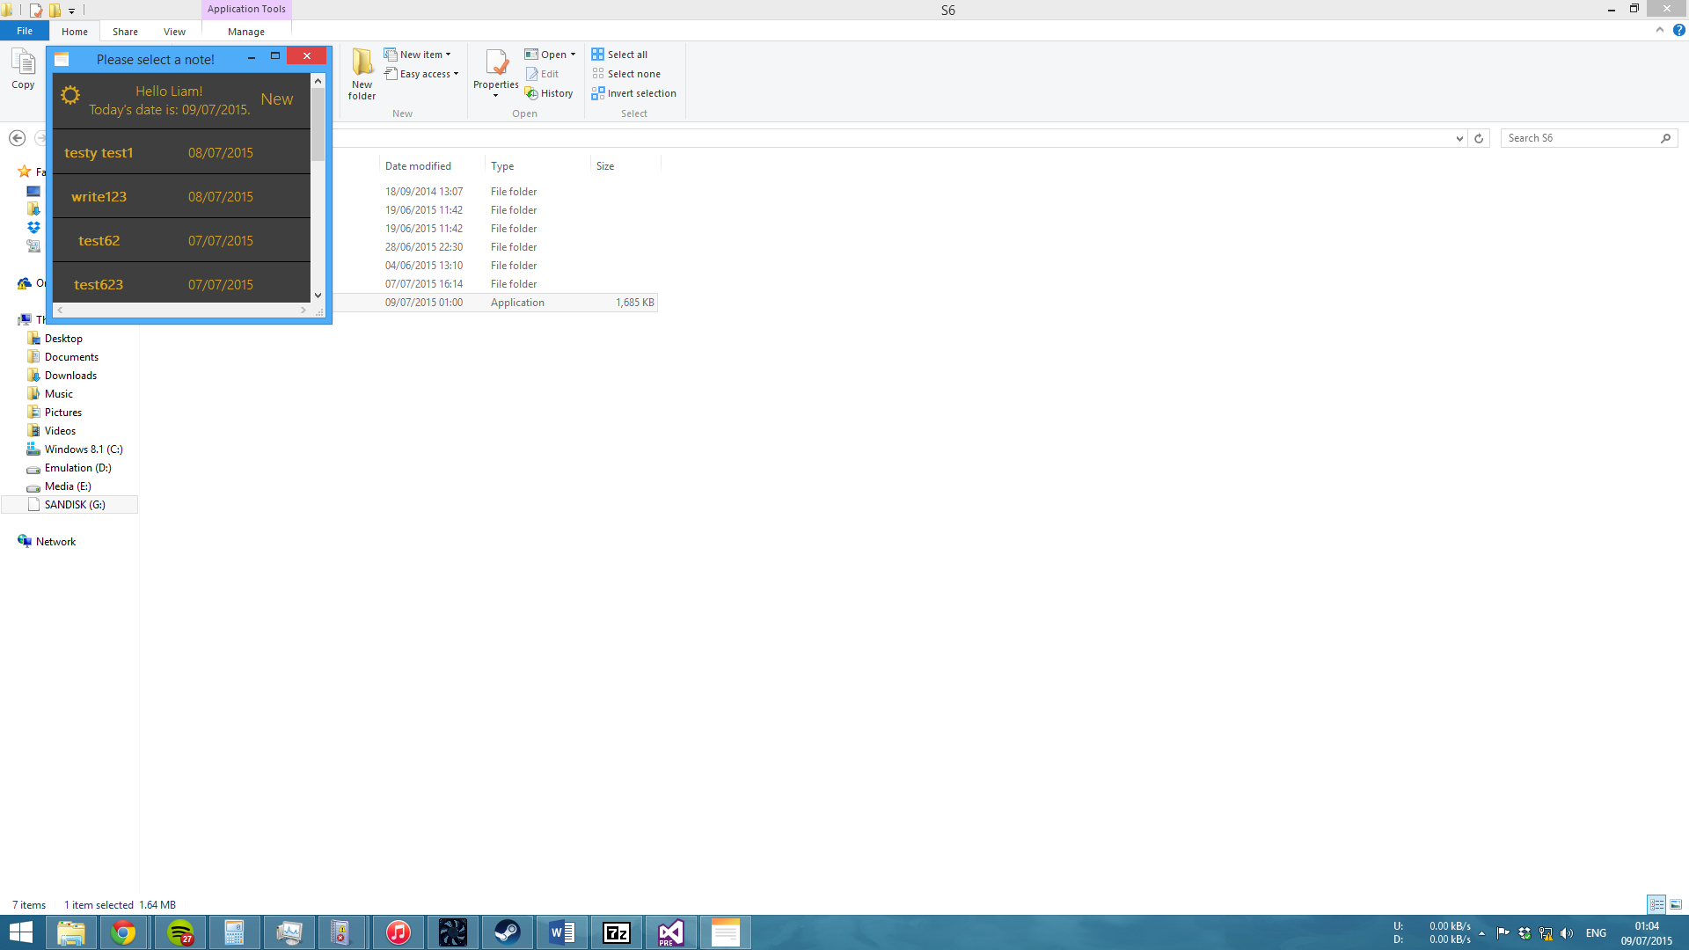

Lastly, the border surrounding the pug in the About form has been removed due to it standing out too much using the dark theme.

09/07/2015 –

The encryption and password authentication sub-routines have been moved into newly created modules (one for each aspect) from the Welcome form.

This is an added effort to further increase the readability of the code. Doing so alters the chain of events of the program. Rather than having the following process occur:

cmdInitialisation 🡪 EncryptionProcess 🡪 Result

+ Authentication

The below occurs instead:

cmdInitialisation 🡪 EncryptionProcess 🡪 Authentication 🡪 Result

The improves readability and aids debugging as the processes now runs sequentially rather than having the authentication module being called inside the EncryptionProcess module.

The only issue encountered with the modularising was that the program would only accept the correct password upon the 2nd attempt. This was solved by passing the SHAstr variable as ByRef rather than ByVal.

In accordance with the change in the chain of events involving the user’s password the user can now change their password at will using the settings form. This was the main reason for the modularisation of the two processes. This is because both processes would have to be called twice during runtime if the user decided to change their password (once for start-up, the next for the change itself). As the processes were embedded in the Welcome form at the time the Welcome form would have to be reloaded. In addition to this the sub-routines would have to be made public instead of private in order to be launched from another form. In conclusion modularising the processes was a much more efficient option.

As we can now change the password this means that the previous hash and salt must be removed from the database. In the program there was a section of code that was rendered useless via the use of ‘. This made it appear as a comment and not run. The section of code was responsible for clearing the tables in the database but however was sectioned off as the code slows down the program and takes several seconds to clear the tables.

The program can now be switched between English and Spanish at will using the Settings form. This works in the same manner as the themes do and is also persistent across executions. As such a new module has been created that contains the replacement strings in order to reduce clutter in the main forms.

If the Spanish button has been clicked on in the Settings form an ‘Easter egg’ is displayed.

Due to the lack of replacing characters with asterisks when using input boxes within the programming environment a new form will have be created that will function as a framework for all output to the user. The ‘Easter Egg’ utilises this. This will mainly be used to substitute password input with asterisks for increased security.

Today also presents the largest increase in code in terms of lines so far. The code line count has increased from 783 to 1107. This is mainly due to the inclusion of the language replacements and the creation of the framework for output. However once the code has been cleaned up the code line count should hopefully decrease.

Before:

|  |  |  |  |  |
| --- | --- | --- | --- | --- |
| Scope | Project | Namespace | Type | Lines of Code |
| Type | TakeNote (Debug) | TakeNote | About | 64 |
| Type | TakeNote (Debug) | TakeNote | NoteSelection | 205 |
| Type | TakeNote (Debug) | TakeNote | NoteViewer | 95 |
| Type | TakeNote (Debug) | TakeNote | Settings | 115 |
| Type | TakeNote (Debug) | TakeNote | Themes | 40 |
| Type | TakeNote (Debug) | TakeNote | Welcome | 264 |

After:

|  |  |  |  |  |
| --- | --- | --- | --- | --- |
| Scope | Project | Namespace | Type | Lines of Code |
| Type | TakeNote (Debug) | TakeNote | About | 65 |
| Type | TakeNote (Debug) | TakeNote | Authentication | 51 |
| Type | TakeNote (Debug) | TakeNote | EncryptionProcess | 82 |
| Type | TakeNote (Debug) | TakeNote | Languages | 62 |
| Type | TakeNote (Debug) | TakeNote | OutputFramework | 99 |
| Type | TakeNote (Debug) | TakeNote | NoteSelection | 208 |
| Type | TakeNote (Debug) | TakeNote | NoteViewer | 99 |
| Type | TakeNote (Debug) | TakeNote | Settings | 239 |
| Type | TakeNote (Debug) | TakeNote | Themes | 46 |
| Type | TakeNote (Debug) | TakeNote | Welcome | 156 |

16/07/2015 –

The ability to search through the notes within the program itself has been added. To begin with the following code was used:

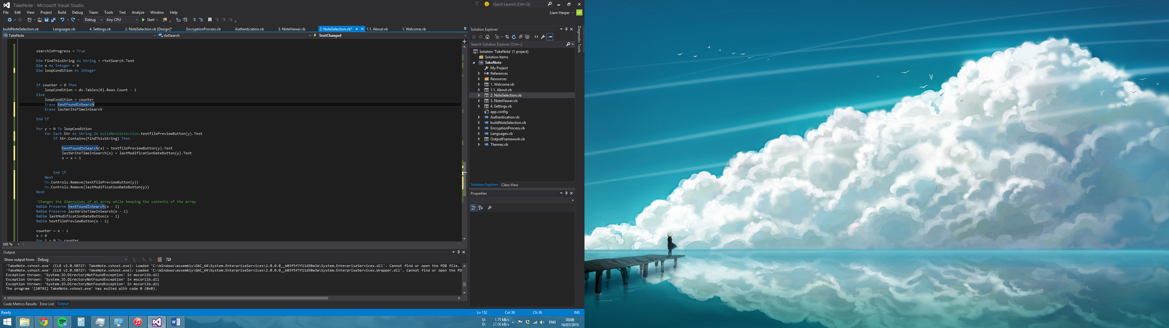

This presented two problems. The first problem was that the code analysed the string for matches character by character. This means that searching using “w” would indeed match with the word “write” as write is broken down into “w”, “r”, “i”, “t” and “e” however using “wr” would result in no results due to “wr” not matching “w”, “r”, “i”, “t” or “e”. The second problem was that if a string has several instances of the same character (for example two t’s in “test”) the program would indeed output “test” twice.

This was resolved by using a different technique to analyse the strings:

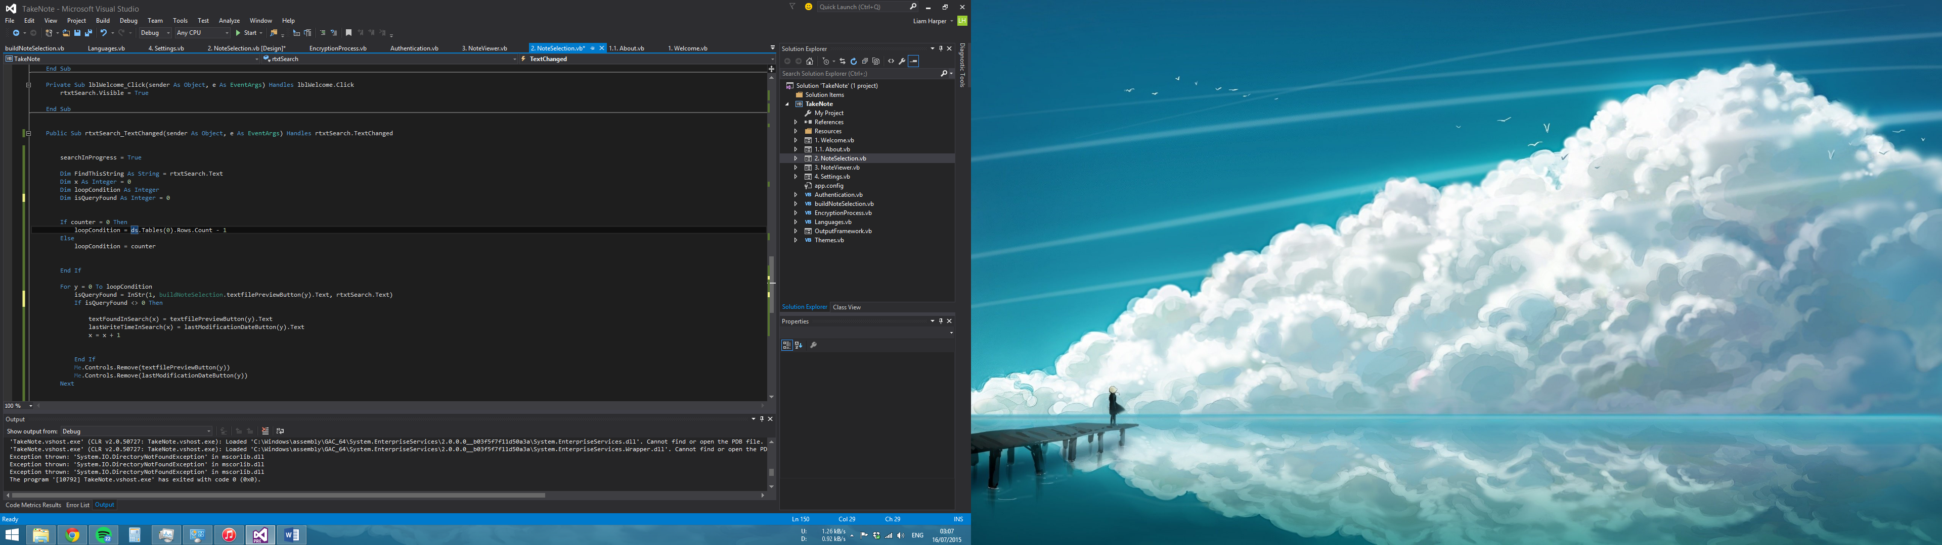

This technique resolves both of the aforementioned issues.

Having the ability to search in the program means that the generated buttons need to be refreshed in order to display only the notes that match the user’s criteria. Rather than copying and pasting the code for managing the generation of the textFilePreview and lastWriteTime buttons into another sub-routine this code has now been placed into a module to reduce unnecessary repetition of code in the program. Doing so creates a problem.

For example if the upper bound of the array that handles how many strings that match the users query is set to 4 via a counter and the upper bound for the loop that controls how many buttons are generated is hard-coded to be set to how many rows of notes are in the users database (for example 9) we will encounter a null reference exception error.

In order to eliminate this the upper bound of the loop that controls how many buttons are produced is modified via an If statement. If the code runs while a search is in progress the number of buttons produced (e.g. the upper loop bound) will become the number of matching strings that have contained the users query. If not the upper loop bound is simply how many rows are in the database containing the user’s notes.

The implementation is not fully complete however due to aspects such as the possibility of the user pressing the backspace needing to be accounted for.

Also during this implementation some deprecated code regarding using file metadata was removed.

17/07/2015 –

Implementation has been put in place in order to accommodate the user pressing the backspace when searching. In order to do this a cache has been created that stores the previous search results. This is currently done via a table in a database.

If the user presses the backspace the program will already know how many times the user has searched in the program via the use of a counter. The program will then contact the searchCache table and retrieve the matching counter number from the AutoNumber field in the database. The row containing the correct AutoNumber will contain our desired previous search data.

This is best shown in the below example:

|  |  |  |
| --- | --- | --- |
| Counter (the number of times the user has searched) | Notes (the resultant notes) | lastWriteTimes (the resultant last write times) |
| 1 (search result 1) | test, test1 | 01/01/1999, 02/02/1998 |
| 2 (search result 2 etc.) | test2, test3 | 03/01/1999, 04/02/1998 |

Once the program receives the search data from the matching counter number row the contents of the “notes” and “lastWriteTimes” field will be split into two separate arrays. These two new arrays will then simply re-populate the form in the same fashion as the implementation that was put in the place in the previous day.

An issue encountered today was that upon clicking a button generated via a search the text that is displayed upon the loading of the NoteViewer form was the equivalent of not searching at all. This is due to our reliance on the array called noteFromDatabase to determine the source

For example:

noteFromDatabase(0) = “test”

29/07/2015 –

The search function in the program is further being worked on. The search function is now capable of dynamically giving the user the result of their last search when they press the backspace. Interestingly enough during implementing this a flaw in the program was noticed and amended. This problem has most likely been hiding since the initial implementation of the NoteSelection form.

The problem was that the value of the index for generating the buttons was invalid. For example this resulted in the user receiving 12 out of 13 of their notes. The realisation came after changing how the upper bound of the array was given when using ReDim. Previously the upper bound of the array was determined by how many rows were in the dataset that contained our notes. However when searching the dataset must be reset in order to be refilled with the users criteria meaning that if for example we wish to make our search field null and display the results that were shown when the form loaded the program will use the number of rows in the narrowed down dataset as an upper bound.

To counter this error the upper bound is now determined by the length of the notesFromDatabase array (providing the variable that determines whether a search is or is not in progress is false). This is used because this variable is a constant and is not modified outside of the form load. This contains our initial data and as a result the index will always be that of our initial load.

01/08/2015 -

Commentary is being rewritten and added in order to fit the new modifications in the program.

03/08/2015 –

Commentary is still being rewritten and added in order to fit the new modifications in the program.

Adjusted the upper bound of byteRNG. The program generates a 32 bit salt and byteRNG was declared as byteRNG(32), instead of the correct version of byteRNG(31).

Some deprecated code has been removed that was associated with having the notes in a text file.

The variable “superSaiyanSalty” is now “plaintextPasswordCombinedWithSalt” as it is unlikely that someone else reviewing the code has a knowledge of Dragon Ball Z and will not understand the meaning of the variable.

The subroutine name of “cmdHashAndSaltPls” is now “cmdReceiveHashAndSaltFromDatabase” in order to make the code look more formal. In addition to this that someone else reviewing the code may not understand the meaning of “pls” (abbreviated form of please).

04/08/2015 –

The entire implementation for searching was deleted as it became so untidy and convoluted it made me nauseous. Upon attempting the implementation again we now have a fully working search function within the program. Funnily enough the whole idea of caching the searches and any interaction with the database during searching was completely unnecessary which reduced the complexity of the code significantly. An issue presented itself afterwards in that the InStr function would not recognise L and l as a match due to their different cases. Meaning that invalid search results would be given.

The following amends this:

Before:

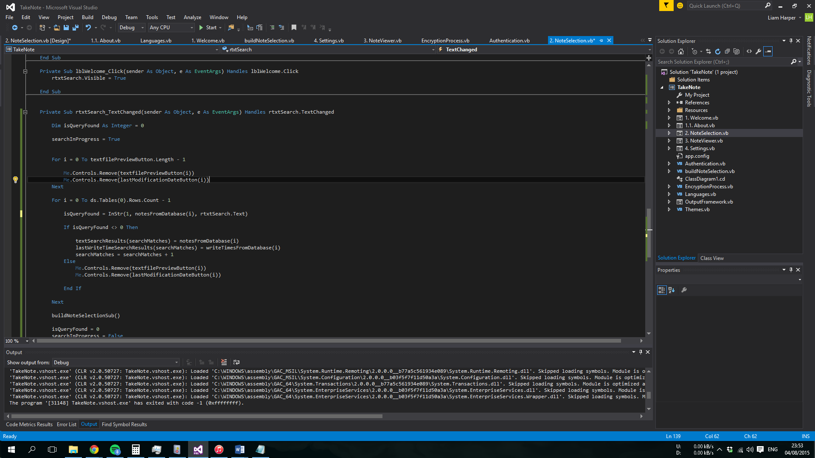

After:

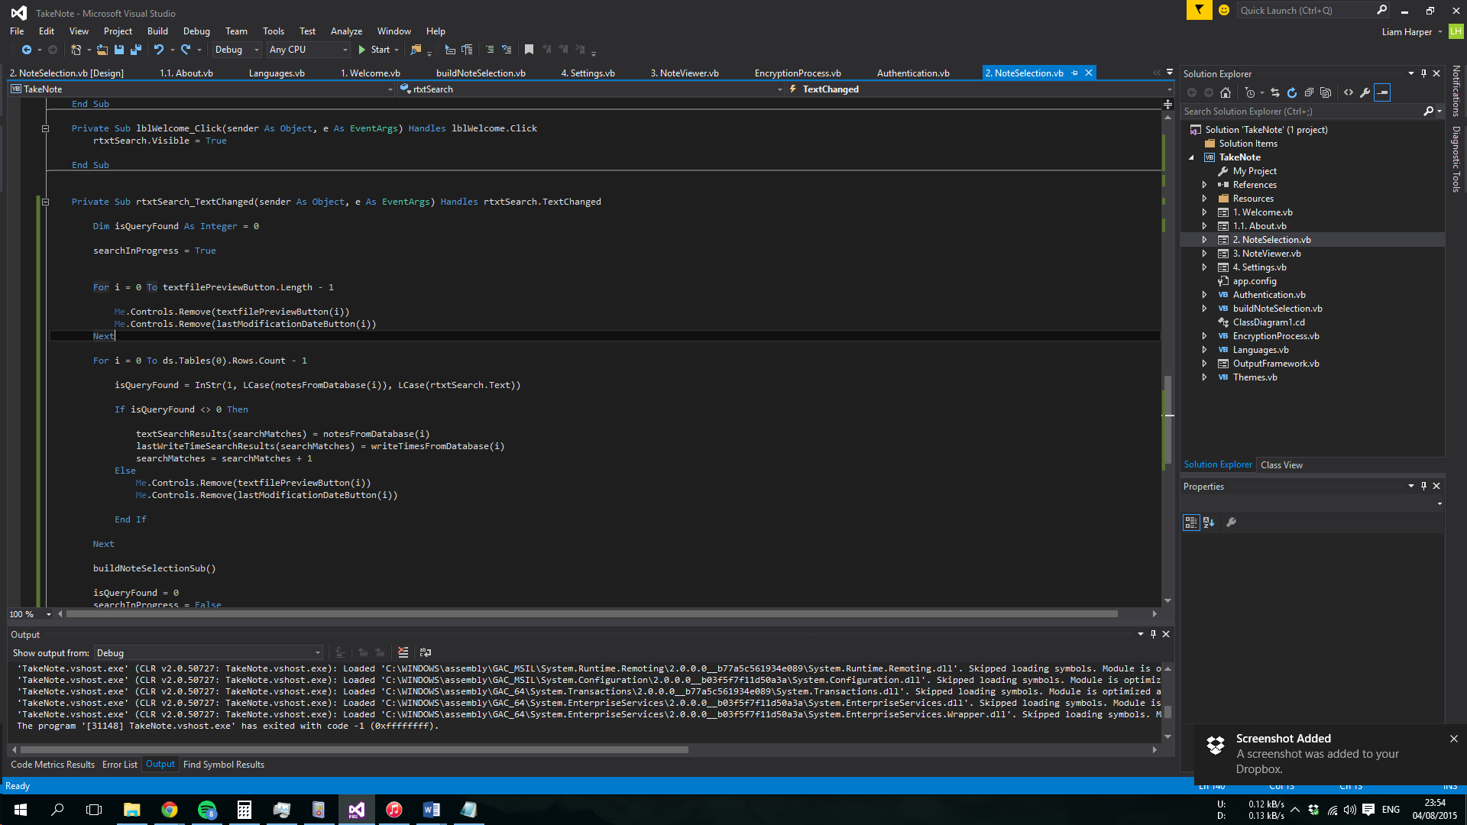

As you can see the method to solve this is to simply force InStr to compare the notesFromDatabase and the search query in a unified case.

Due to this impending implementation the code in the NoteSelection form was not cleaned out like the others due to not wanting to modify the form until it is complete. Now that it has been completed some adjustments have been made:

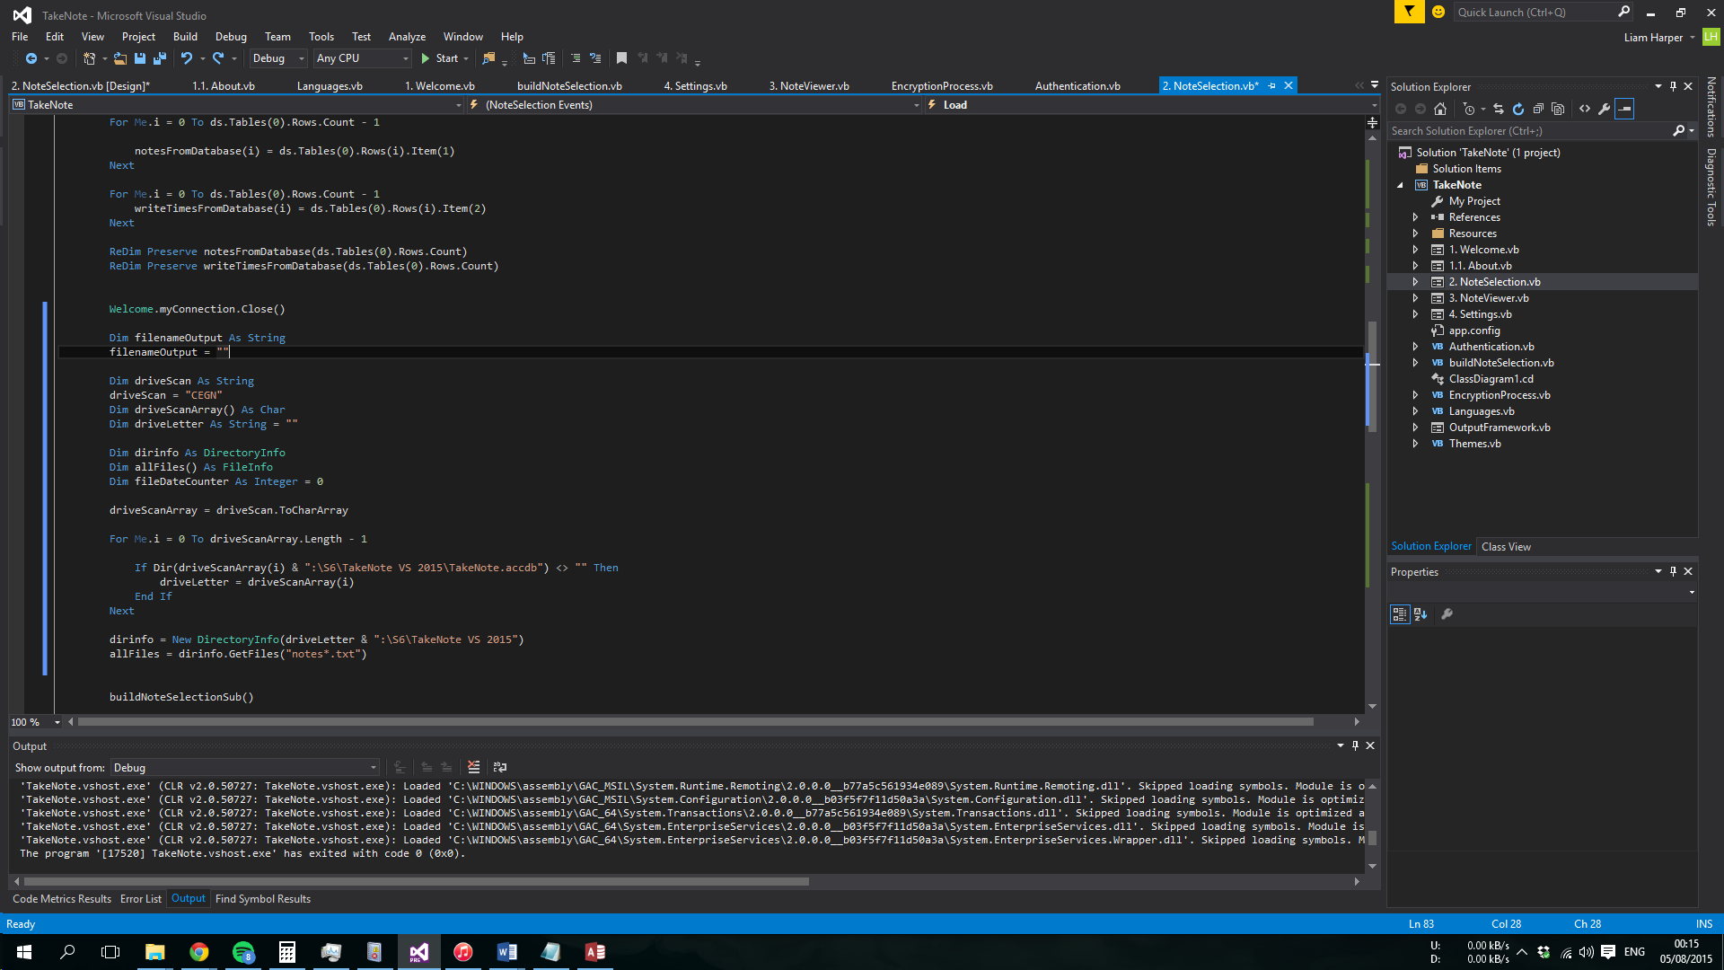All the variables and code you see to your left is useless and has been removed!

Commentary is now finished on the project as it stands.

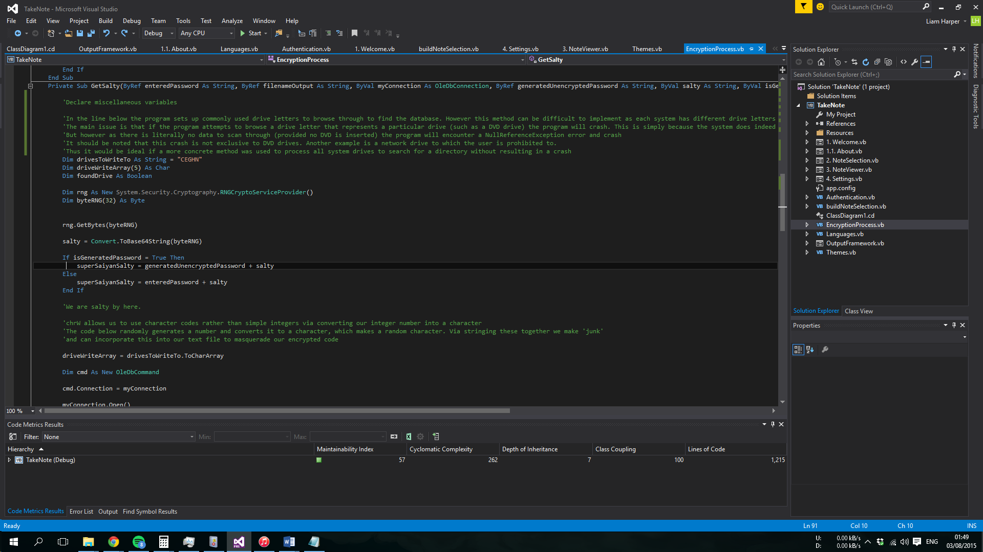After cleaning the NoteSelection form and the buildNoteSelection module the code metrics have altered as such:

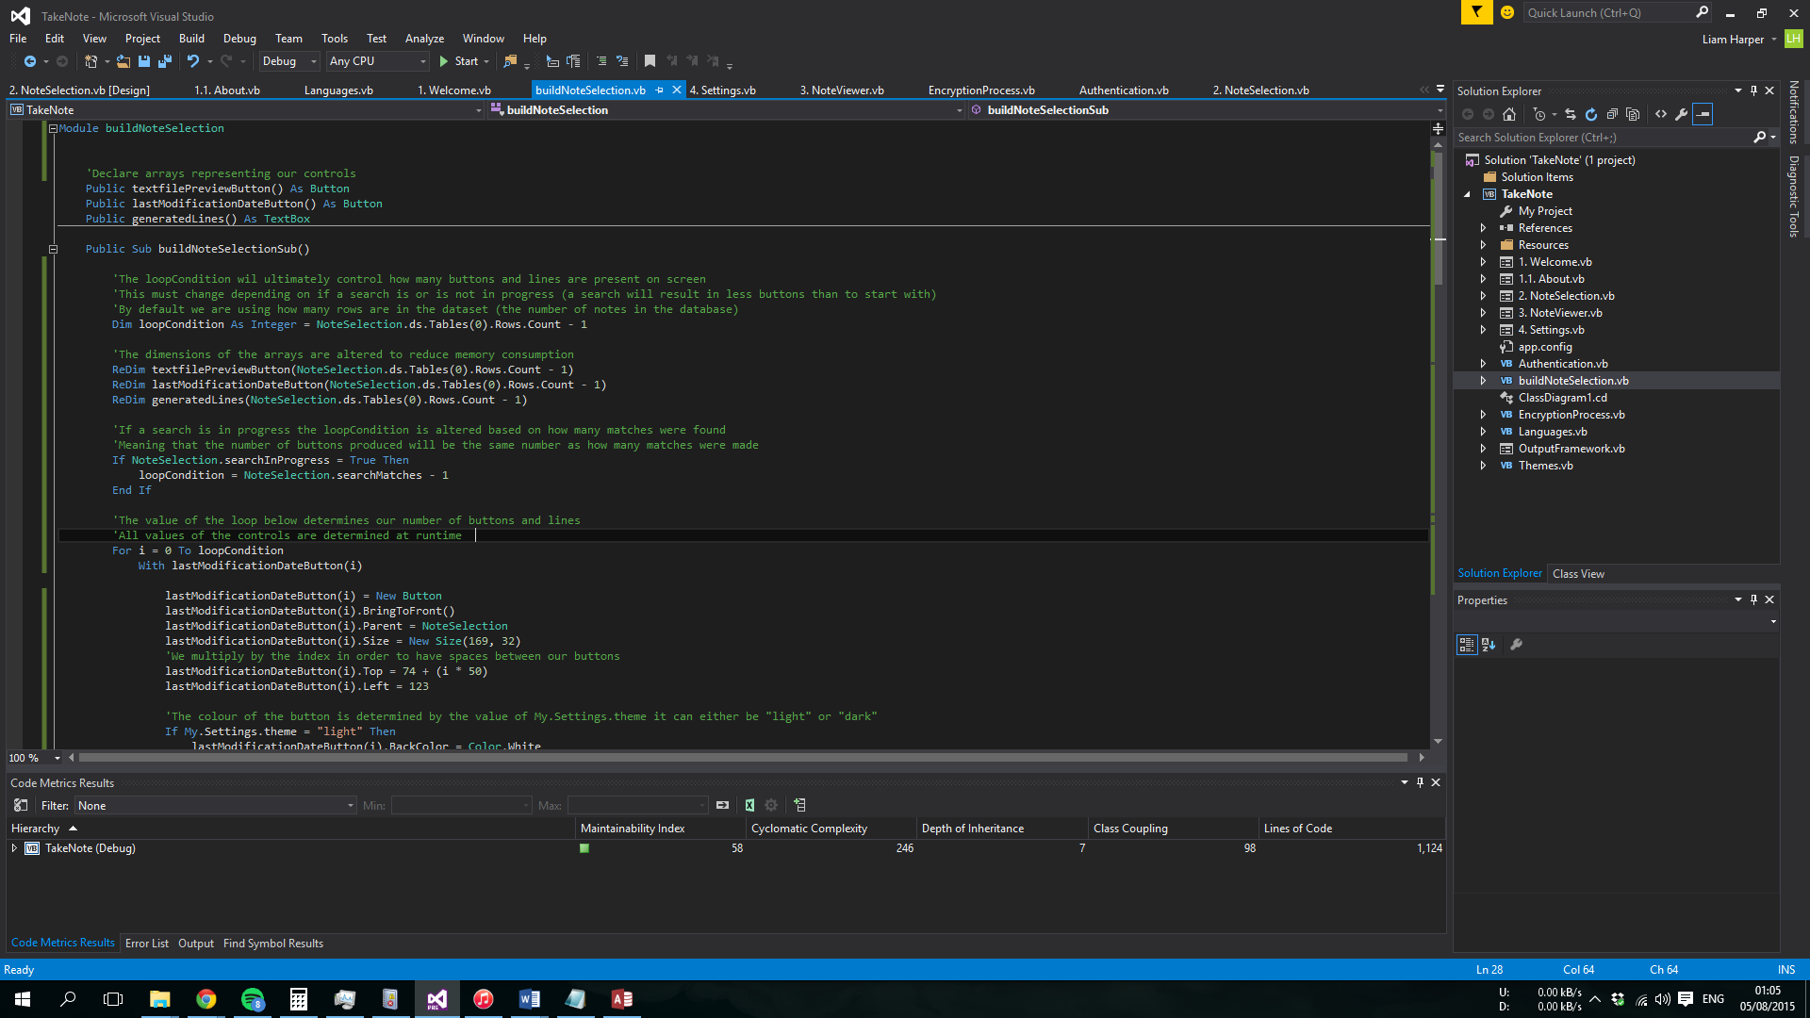

06/08/2015 –

The outputFramework is now complete meaning that an input box is no longer used for password input. Instead a form made to look an input box has been created that masks the entered keys in the text box with asterisks.

The only modification to external code is the movement of lines that initialise the sub-routines. These have been moved from the Welcome form into the OutputFramework form in order for them to be launched when the user clicks the Ok button on the form to submit their password.

Commentary has been added in accordance of this.

The search text box is no longer triggered by clicking the welcome label on the NoteSelection form and instead has its own icon on the same manner as the settings icon. When the icon is clicked the text in the welcome label is now modified to display a relevant message to the user. Upon clicking the search icon again the welcome message will revert to normal and the search text box will become hidden again.

After checking the functionality of all of the other aspects of the program it was realised that editing a note would crash the program with the error “There is no row at position 14”. This was caused by our index from the openTextFile sub-routine being changed upon a previous rewrite. Previously the following would occur:

i = trimmedButtonName

And afterwards “i” would be passed on into the NoteViewer form. However as this line no longer exists NoteViewer uses the index used elsewhere in the program (to compute how many rows there are in the programs dataset) which has an upperbound of 13 at the time of the crash, hence the error as 14 cannot be contained.

The solution to this is to simply refer to trimmedButtonName instead of “i” in the noteViewer form.

At this point all intended features are complete and this means that code and design refinement are all that remain to create the completed program.

11/08/2015 –

The user can now delete notes in addition to the previous feature of saving them.

Also to help the user progress through the program in a smooth manner the password entry screen automatically highlights the textbox. This saves the user time so they don’t have to do this manually. Also if the user presses enter in the form the click event for the Ok button will be triggered. This keeps the program in line with modern programs and once again saves time.

An error in the application of the light theme on the password selection screen was fixed. The background for the label asking the user to enter their password was Goldenrod instead of white.

All forms are now set to a fixed size and cannot be adjusted by the user. This is because the generated elements of the form do not adjust when the form is resized.

The program now also has a setup file that will install the program to a specified directory. This is so that the user is guaranteed to have a blank database along with the program. Currently the program still scans for a pre-set directory and this will have to be adjusted to take the setup file into account. The setup file however adds a registry entry containing the install directory which will be used by the program.

17/08/2015 –

A problem that has been noticed since the implementation of the search feature has been resolved. Upon either entering a search query or after closing the search window (the error only occurs if the search box has been closed AFTER a search query has been made) all elements on the form shift right. After a long period of trial and error this was found to be caused by the programs method of hiding the horizontal scroll bar but keeping the vertical scroll bar (a lazy method that saved me resizing the form elements so that the horizontal scroll bar didn’t appear regardless of the AutoScroll property being enabled). This was resolved by resizing the NoteSelection form appropriately which removed the horizontal scrollbar completely.

As such the NoteSelection form looks much cleaner and has had elements adjusted slightly. For example the buttons are more centred and some gaps between form elements have been reduced.

Also, the very apparent flickering upon entering a search query has been resolved too. This is caused by the form updating as the code goes along rather than updating all adjusted elements simultaneously. This is resolved by adding “NoteSelection.SuspendLayout” at the beginning of the buildNoteSelection module and adding “NoteSelection.ResumeLayout”. These two lines of code allow the program to update the form after all changes have been completed rather than as the code goes along via freezing the UI and preventing modifications to the form then unfreezing the UI once all code changes have been made, thus allowing a simultaneous update of all changed elements.

The delete button on the NoteViewer form somehow broke when it worked previously. A new method of checking if the yes button on the message box was clicked has been implemented and it is now fixed.

Also, if the user created a new note and the “changes saved successfully” message box appeared and was closed the NoteViewer form was still open. Meaning that if the user clicks save again a second instance of the same note will be created. This will resolved by adding “Me.Close” after the message box was displayed. The “Me.Close” method was already implemented when the user deleted a note (only for the English message however, which has also been fixed) but was missed out regarding the save option.

The size of the “Please enter your password” label on the OutputFramework form has been reduced to make the form look neater.

The size of the folder containing all project files has been reduced from 50mb to 36mb through a clean-up.

20/08/2015 –

The program can now utilise the registry in order to find the database directory. As the solution stands we can take the database from both a removable thumb drive (for use when debugging) and also the install directory that can be used along with the setup file. The former will be removed in the final product.

All aspects of database management are now in their own module. This allows for cleaner code in all forms and simplifies the use of variables related to the database throughout the program.

A new feature is being implemented where a user can select a wider range of colours. In addition to this hovering the cursor over the colour (a label with the back colour indicating what colour is being selected) will modify the NoteSelection and Setting form until the mouse is taken off of the colour in which it will then return to the colour that was present prior to selection.

As it stands the process of doing this is currently done through the use of a class. This reduces repetition significantly as we only need to run one block of code once no matter what colour is highlighted. This is done by transferring the back colour of the label and the user’s current selected colour into the class.

21/08/2015 –

The previous implementation of having two buttons to change themes (dark and light) has now been deprecated and the method that was started the previous day is now complete. The user can place the mouse over a label to see a preview of what it will look like. Taking the cursor away reverts the preview. Clicking the label applies that theme and gives it persistence between executions. The user can also enter a custom colour via the use of a button. However the only colours that the program will accept are System.Drawing.<Color> used within the programming environment.

The program now comes with the Segoi UI font. This means that no matter what operating system the program runs on the interface with use the Segoi UI font. For example in Windows 8 < systems Segoi UI does not exist and Microsoft Sans Serif is used instead. This resulted in misplaced form elements due to the difference in size. This will no longer occur. An accidental benefit of this is that during the implementation the Segoi UI was added to elements that previously were left as default. As a result of this areas of the program look neater than before.

This issue that occurs when > 5 buttons are present on the NoteSelection form has been amended. The form elements now adjust depending on whether or not the vertical scrollbar is present.

The easter egg now only displays when a particular note is present in the program.

The program can now be ran independently off a USB drive.

11/10/2015 –

The easter egg was broken due to misplaced code and is now functioning correctly. The English string for “Custom:” in the settings form was missing meaning changing from Spanish to English would result in the string in the custom theme button remaining as Spanish. The English string has been added.

**IF I MAKE A SEARCH WITH NO NOTES WILL A CRASH OCCUR????**

1. 07/07/2015 – Added title and icon to Record of Progress.
2. 07/07/2015 – At the beginning of development a record of progress existed on my home drive. However I forgot to copy that to my USB drive and this meant a new record of progress had to be created at school. This means that the entries from the 5th to the 8th are simply copied from the old record of progress to here.
3. 07/07/2015 - The previous and current paragraph was formatted incorrectly. This has been altered to match the formatting of the rest of the document.
4. 07/07/2015 – Changed from ascending to descending.
5. 10/07/2015 – Typing mistake (Missed the word “the”)